**JS Latest Features:-**

**ES12(JS 2021):**

1. **replaceAll-**   
   given a string

const string = "Javascript is the best web scripting language. Javascript can be used for both front end and backend";

and we want to replace the word Javascript with Typescript at all the places it occurs in the string  
we normally would use the replace method which replace only the first occurrence of the word and o we have to loop till there is no word present in the string



But to replace all the occurrence at one go :-

Use replaceAll:-



1. **Private Methods**

Lets create a class with two methods :-

We can make the method private by using # with its name when it is defined:-

As showAge is a private method now we cannot directly access it

It can only be accessed only inside the class  
so the solution:-

1. **Private Accessors**  
   Text

   Description automatically generated

When we make Age as private

It returns undefined

Solution:-

Make a public method inside class that can access return the result of this private accessor

1. **Promise.any()**

**Promise.any()** is like the opposite of Promise.all(). Promise.any() resolves if any of the supplied promised is resolved unlike promise.all() which waits for all promises to resolve before it resolves.

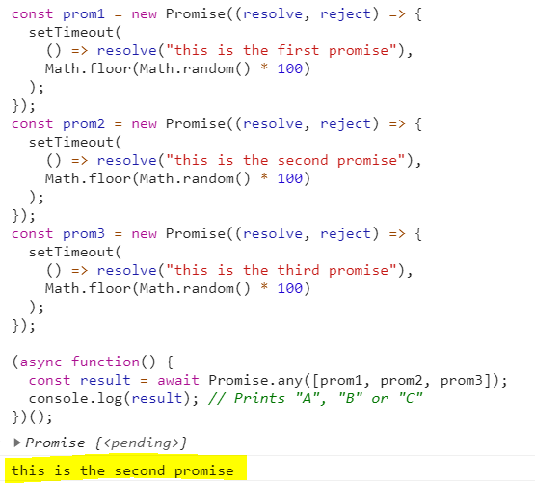

What if no promise resolves-  
 Well, Promise.any() throws an AggregateError exception. We will handle it in a try catch block.

1. **Numeric Separators**

Binary Literals

1. **Logical Assignment Operator**

With &&

This is what is actually going on:-

&& = both values needs to be true , so assignment occurs if x is truthy  
|| = finds the first true value so assignment occurs if x is falsy

??= works as || expect that it only check for the value is undefined or null and not completely falsy.

Undefined:-

Defined:-

Difference in || and ??

NaN is a falsy value but is not undefined or null

||=

??=

